NAVIGATION AND CONNECTION LIBRARY REMEDIATION APPLICATION

TCS PLANNED DOCUMENTATION

24 April 2020

Contents

NAVIGATION AND CONNECTION LIBRARY REMEDIATION APPLICATION 1

TCS PLANNED DOCUMENTATION 1

1. PURPOSE 1

2. INTRODUCTION 2

3. TECHNICAL DETAILS 3

.1 BRIEF EXPLANATION OF EACH FUNCTION 3

.1.1 GetQuickLaunchValue 3

.1.2 AddMissingLink 3

.1.3 CheckMigrateAndReplace 4

.1.4 WriteOnPremSites 5

.1.5 LogReplacedSites 6

.1.6 LogInfo 7

.1.7 ConnectedLibraryOperations 8

.1.8 ReplaceConnectedLibraryLinks 9

1. PURPOSE

This document contains all technical of EYOS Migration Navigation AND Connected Libraries Remediation application

1. INTRODUCTION

This utility was build based on the requirement that structure of quick launch in source site should be same as destination sites. Additionally, it is doing content migration of connection library from source site to destination site.

1. TECHNICAL DETAILS

## BRIEF EXPLANATION OF EACH FUNCTION

### GetQuickLaunchValue

Retrieve the quick launch values from source and destination sites

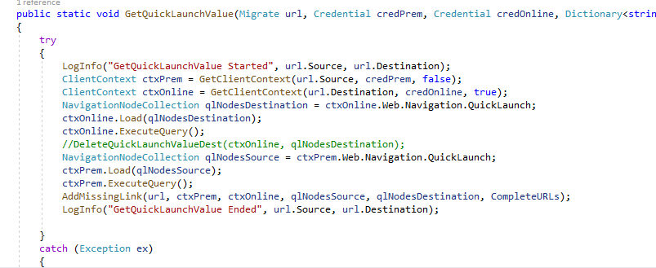

### AddMissingLink

Find out missing link in destination and redirect to **CheckMigratedAndReplace** function which will replace the source URL with destination URL and after replacement it will be added to destination site.

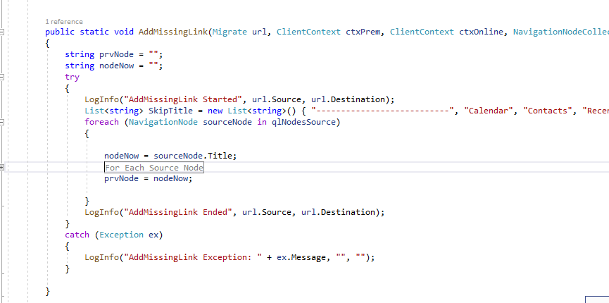

### CheckMigrateAndReplace

Replace the source URL with destination URL

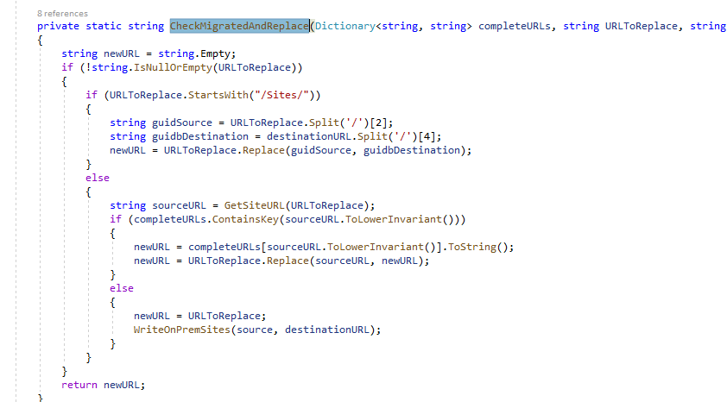

### WriteOnPremSites

This will log the details of On Prem Site added in destination due to site not migrated.

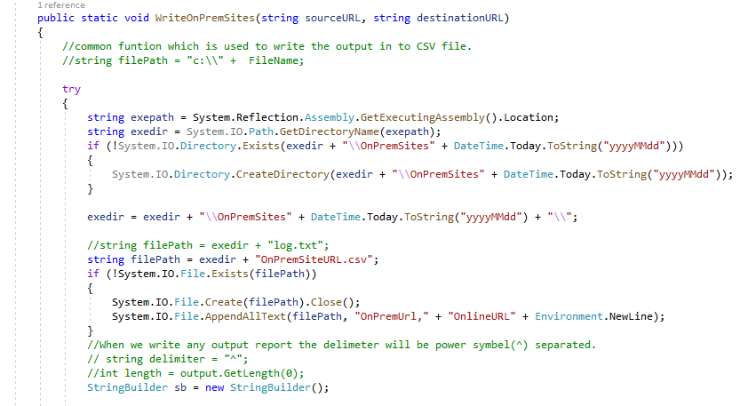

### LogReplacedSites

This will log details of site which are added in destination

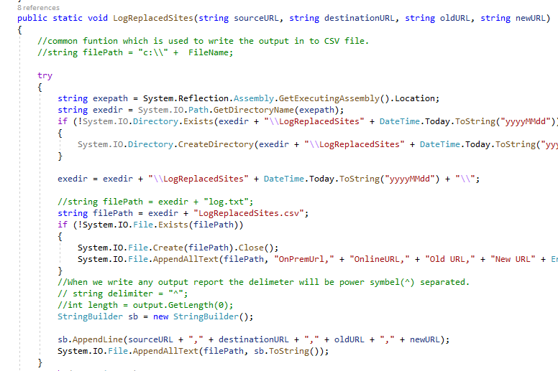

### LogInfo

This will log information of execution and errors

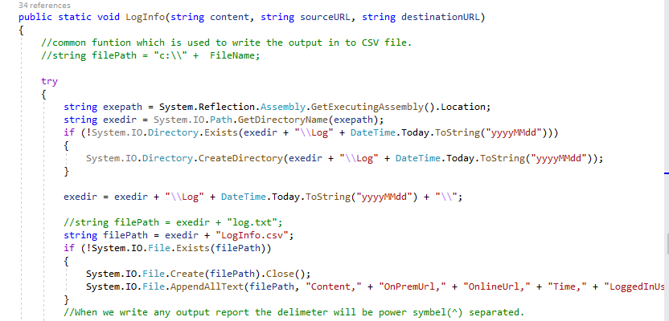

### ConnectedLibraryOperations

This function will perform below operations:

1. Loop through each links present in source Connected Library and Lists.
2. Check if link belongs to a different site.
3. If Yes, check if the link got migrated.
4. If yes, add the newly migrated link in destination Connected Library.
5. If the link is not migrated, then add the link without any changes.

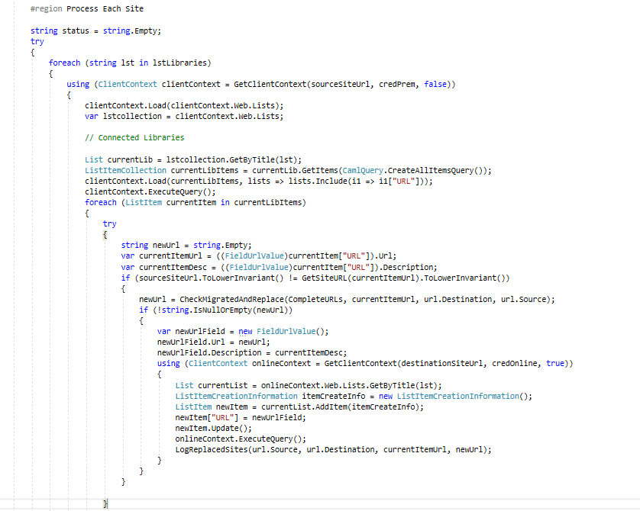

### ReplaceConnectedLibraryLinks

This function will perform below operations:

1. Loop through each links present in destination Connected Library and Lists.
2. Check if link belongs to a different site.
3. If Yes, check if the link got migrated.
4. If yes, update the newly migrated link in destination Connected Library.
5. If the link is not migrated, then make no changes.

